It’s Our River Day – Event and Contact Sheet
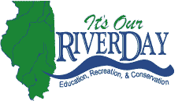

Name of community: _______________________________________

Contact information for Illinois River Coordinating Council (will not appear on website):

Name: _______________________________________

Address: _____________________________________

Phone: _______________________________________

E-mail: _______________________________________

Information on Website Listing (will appear on website):

Name of event: _______________________________________
Type of event (check all that apply): Recreation ___ Education ___ Conservation ___

Time: _______________________________________

Location: _______________________________________

Date: _______________________________________

Fee/Free: _______________________________________

Brief description of the event:

Website (To link to, if applicable): _______________________________________

Contact for more information (public contact): _________________________________

Sponsors:
_______________________________________

_______________________________________

_______________________________________

_________________________________

Please fill out and return to:
Olivia Dorothy
Office of Governor Pat Quinn
414 Stratton Building
Springfield, IL 62706-4700
Fax: 217-782-9879

