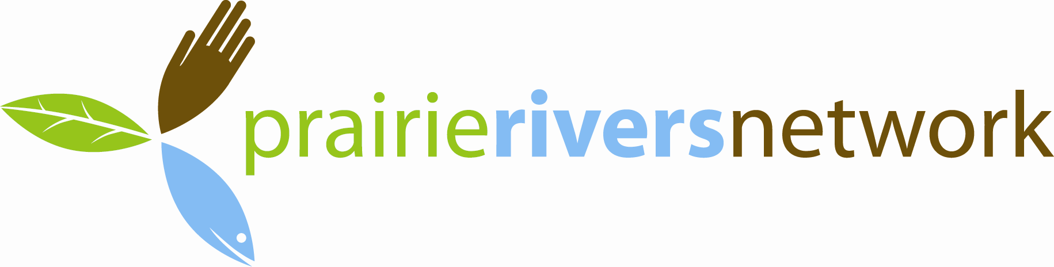

2011 Annual Dinner Sponsorship
When: Friday, October 14, 2011; Reception 6 pm; Dinner 7: 30 pm
What: A celebration of Illinois’ rivers and streams by 300 engaged citizens that support clean water and healthy rivers
Keynote Speaker: Gene Karpinski, President of the League of Conservation Voters
Where: I Hotel and Conference Center, 1900 S. First Street, Champaign, IL 61820
Price: $50 per person or $400 for a table of 10; Reservations Required
SPONSOR LEVEL | SPONSOR BENEFITS
PLATINUM  $5,000 | - 8 tickets to dinner with premium seating  - Recognition in press release  - Opportunity to speak to audience at dinner  - Recognition by board member and slideshow during dinner  - Prominent mention in program, posters, website, newsletter  - Display table space during cocktail hour
GOLD  $1,000 | - 4 tickets to dinner with premium seating  - Slideshow recognition during dinner  - Prominent mention in program, posters, website, newsletter  - Display table space during cocktail hour
SILVER  $500 | - 2 complimentary tickets to dinner  - Recognition in program, posters, website  - Display table space during cocktail hour
BRONZE  $250 | - Recognition in program, posters, website  - Display table space during cocktail hour

PRAIRIE RIVERS NETWORK SPONSORSHIP LEVELS
$5,000: Platinum Sponsor
$1,000: Gold Sponsor
$500: Silver Sponsor
$250: Bronze Sponsor

I am unable to sponsor but would like to contribute $_______________ to support Prairie Rivers Network important work.
Please contact me about specialized sponsorship opportunities.

Please return completed form to: Steph Adams
Prairie Rivers Network
1902 Fox Drive, Suite G
Champaign, IL 61820

Individual or Company Name (as you would like it to appear on all printed materials):
Contact Name:
Address:
City, State, Zip:
Phone: |  | Email:

Enclosed is my check, payable to Prairie Rivers Network, for the amount of $ .

Charge my credit card for the amount of $ .
Card Number:
Name on card:
Signature:
Expiration Date: |  | Security Code:

Credit card donations are processed online through Network for Good.

