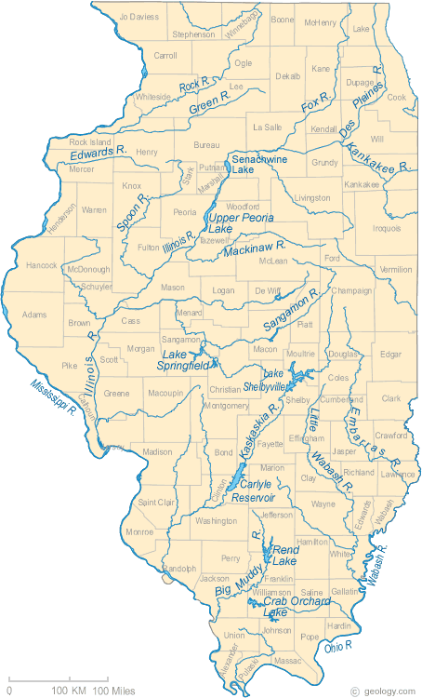

Illinois Rivers Shown on the Map: Big Muddy River, Des Plaines River, Edwards River, Embarras River, Fox River, Green River, Illinois River, Kankakee River, Kaskaskia River, Little Wabash River, Mackinaw River, Mississippi River, Ohio River, Rock River, Sangamon River, Spoon River and Wabash River.
Illinois Lakes Shown on the Map: Carlyle Reservoir, Crab Orchard Lake, Lake Shelbyville, Lake Springfield, Rend Lake, Senachwine Lake and Upper Peoria Lake.

