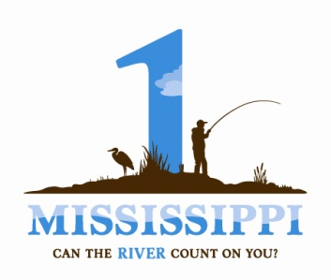
Our Upper Mississippi River: Connection, Inspiration, Transformation
Essay Contest Entry Form
Please fill out the entry form completely and submit it electronically to: csmith@prairierivers.org
Submission Deadline: 11:59 PM, Friday March 16, 2012

Name:
Address:
Phone:
Email:
Essay Title:
Word length (not including title):
Disclaimer: In submitting this entry form, I acknowledge that I have read and understand the official rules of the UMR Essay Contest. I understand that judging is subjective and I agree to abide by the decision of the judges and/or contest officials. I shall hold harmless the Prairie Rivers Network and 1 Mississippi Campaign/Biodiversity Project, contest personnel and/or judges for any and all disputes arising from circumstances beyond the control of the contest officials.
For questions, contact Cecily Smith. csmith@prairierivers.org, 217.351.0927

