 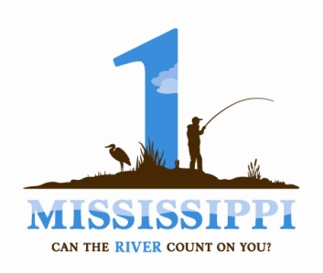

**“Our Upper Mississippi River: Connection, Inspiration, Transformation” Essay Contest Entry Form**

**Contest Information:** [**http://prairierivers.org/umressay/**](http://prairierivers.org/umressay/)

Please fill out the entry form **completely** and submit it **electronically** to: [csmith@prairierivers.org](mailto:csmith@prairierivers.org)

**Submission Deadline**: 11:59 PM, Friday March 16, 2012

Name:

Address:

Phone:

Email:

Essay Title:

Word length (not including title):

Disclaimer: In submitting this entry form, I acknowledge that I have read and understand the official rules of the UMR Essay Contest. I understand that judging is subjective and I agree to abide by the decision of the judges and/or contest officials. I shall hold harmless the Prairie Rivers Network and 1 Mississippi Campaign/Biodiversity Project, contest personnel and/or judges for any and all disputes arising from circumstances beyond the control of the contest officials.

For questions, contact Cecily Smith. [csmith@prairierivers.org](mailto:csmith@prairierivers.org), 217.351.0927