 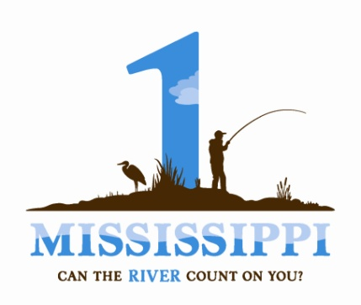

**“Our Upper Mississippi River: Connection, Inspiration, Transformation” Essay Contest Guidelines and Rules**

**Contest Information:** [**http://prairierivers.org/umressay/**](http://prairierivers.org/umressay/)

**Please read these rules carefully; failure to follow them will disqualify you. If you have any questions, please contact Cecily Smith BEFORE you submit your essay (**[**csmith@prairierivers.org**](mailto:csmith@prairierivers.org)**, 217.344.2371).**

1. Contestants must be current residents of Illinois, Iowa, Minnesota, Missouri, or Wisconsin and at least 18 years old.

2. No entry fee is required.

3. Each entrant may submit only one essay.

4. Essays can be submitted from Monday, January 2, 2012 through 11:59 PM, Friday, March 16, 2012.

5. All entries must be original works, in English. Plagiarism, which includes the use of third-party poetry, prose, song lyrics, characters or another person's ideas, without written permission or proper acknowledgment will result in disqualification.

6. Entries may not have been previously published in professional media.

7. To be eligible, entries must be works of prose, 750 to 1,000 words in length, not including the title (grammar, punctuation or spelling errors will count against your entry, so proofread thoroughly).

8. Entries, along with the Essay Contest Entry Form, must be submitted in electronic format to [csmith@prairierivers.org](mailto:csmith@prairierivers.org). Personal information will not be used by us, or provided to anyone else, for any purpose other than to identify you as a contestant.

9. All entries must be double spaced, and use Times Roman or Calibri 12-point font.

10. Every essay page must contain the essay title and page number, but NOT the author's name or contact information (to facilitate fair judging).

11. All entries are final. No revisions are accepted.

12. The decisions of the judges are entirely their own, and are final.

13. Winner(s) will be individually notified of the results by email the week of April 15, 2012.

14. By entering this contest, you grant Prairie Rivers Network and the 1 Mississippi/ Biodiversity Project exclusive rights for a period of 90 days, should your essay be chosen as a winner, as well as a non-exclusive right to: a) use the essay indefinitely for educational and promotional purposes (giving credit to the essay author); and b) maintain a copy of the essay in each organization’s archives indefinitely. "Exclusive rights" means that you agree not to publish your work for a 90-day period, which begins the date the winner is notified. "Publish" means any public display of your work, and includes your personal website and posting to message boards. You are welcome to link to the page featuring your work instead, and once the 90-day exclusive-rights period has ended, you are free to re-publish your work online.