

**Climate Science Speakers Bureau**

<http://ilheartland.sites.acs.org/climatespeakersbureau.htm>

The Illinois Heartland Local Section of the American Chemical Society is pleased to offer a Climate Sci­ence Speakers Bureau. The section was awarded a Climate Science Challenge Grant by the American Chemical Society in 2013. We have been active in presenting workshops for teachers, training the Chemistry Clubs in our section to demon­strate climate science chemistry, and presenting educational demonstrations at the state and county fairs, Earth Expo, Scary Park and other public events. We welcome invitations to schools and to civic, environmental, church & youth organizations.

The Speakers are scientists concerned about climate change and the problems that it will create with increasing intensity and cost to society if CO2 emissions continue unabated. Four speakers currently available have brief biographies on our website with an indication of the distance each of us is willing to travel. For longer distances, some mileage compensation would be appreciated, as well as lodging for a late evening presentation more than 100 miles from our home base.

The graph below illustrates one of many independent lines of evidence for human-induced climate change. The talks will be illustrated and interesting presentations of factual evidence supporting global warming and mankind's contributions. Actions to begin mitigating green-house gas emissions and their consequences will be presented briefly. We will tailor the presentation to the audience and can include demonstrations of climate change chemistry and ocean acidification.

*97% of the world's climate scientists agree that global warming occurs in part due to human activities. The major scientific organizations of the US, and over one hundred world-wide, have released supporting statements. Our present speakers are*

Brent Chandler Frank Shaw Lena Yurs Michael Byrns

Illinois College Illinois State Univ. Illinois Central Collg. Illinois State Univ.

[brent.chandler@ic.edu](mailto:brent.chandler@ic.edu) [cfshaw@ilstu.edu](mailto:cfshaw@ilstu.edu) [lena.yurs@icc.edu](mailto:lena.yurs@icc.edu) [mbyrns@ilstu.edu](mailto:mbyrns@ilstu.edu)

Feel free to contact any of the speakers, perhaps talk to several; additional contact info is in each bio on our website. We look forward to hearing from you. 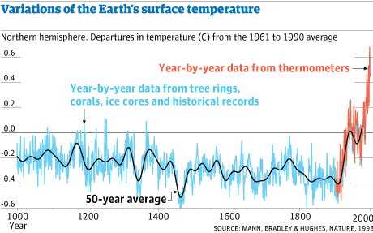We are willing to travel to make presen­tations in the section and near-by areas. The presentation can include many dramatic demon­strations that illustrate the chemistry of climate change and the consequences for the oceans of the world. We can tailor our talks to the audience, from elementary classes to scientific and conservation organizations. Check us out on the website.

*Please share this flyer with schools, civic, environ­mental and church groups in you community*