

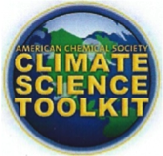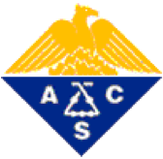

**Climate Science – Fall 2015 Educator Workshops**

***The Illinois Heartland Section of the American Chemical Society (ACS) has an active Climate Science Outreach Program. Three Teachers Workshops will be presented in 2015. A speaker’s bureau of interested scientists who can speak to school classes civic, religious and community groups with demonstrations and/or provide training in climate science demonstrations.***

**Climate Science & the ACS Toolkit**

**($15 registration includes lunch and take-home supplies)**

**August 29, 2015 Illinois State University, Normal IL**

**September 12, 2015 Illinois College, Jacksonville, IL**

**October 24, 2015, Challenger Learning Center, Normal IL (focusing on elementary & middle school teachers)**

Climate change affects everyone and everything, locally and globally.  Extreme weather, melting ice caps, rising sea levels, ocean acidification, food and water supplies, public health, and economic prosperity are familiar features in the media. But when someone asks about global climate change, do you have the basic scientific facts to respond? Bring your questions and concerns and take part in this workshop dedicated to communicating climate change facts, consequences, and responsibilities.

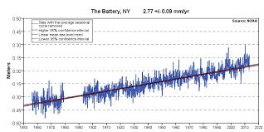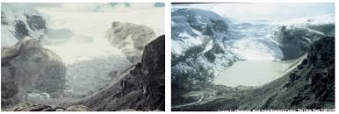Each workshop will include a conservationist or biologist discussing the effects of climate change on ecosystems. The Bloomington Normal workshops will each have a meteorologist or climatologist discussing the differences between weather and climate and counter-intuitive factors such as the arctic vortex. Chemists will introduce the American Chemical Society’s (vritual) Toolkit and other resources which can easily be found on the internet and downloaded without charge and provide hands on instruction for demonstrations that can be used in the classroom and/or outreach activities. The workshop environment is warm, friendly and cooperative. The registration fee covers lunch and the take home tool-kit for the demonstrations.

*Rising Ocean Levels and Disappearing Glaciers are 2 of 10 physical changes which result from and confirm global warming*

Naturalists and Environmental Educators are also welcome to attend. Attendees will be provided with a complete set of the PowerPoint presentations in the Toolkit; pdf files of authoritative climate science booklets that students can download from the internet, a thumb-drive loaded with useful information, including classroom-ready materials. Demonstrations for the classroom (adaptable for hands-on lab experiments) will be explained and performed by each attendee. Instructions and materials for many of these demonstrations will be available for teachers and environmentalists to take back to their school or organization. Teachers will receive five CPDUs for attending the Workshop. Lunch and morn­ing / afternoon refreshments will be provided.

**contacts: Frank Shaw (**[**cfshaw@ilstu.edu**](mailto:cfshaw@ilstu.edu)**); Brent Chandler (**[**brent.chandler@ic.edu**](mailto:brent.chandler@ic.edu)**);**

**Registration via ISU CeMaST:** [**https://survey.lilt.ilstu.edu/TakeSurvey.aspx?SurveyID=l8KI4p932**](https://survey.lilt.ilstu.edu/TakeSurvey.aspx?SurveyID=l8KI4p932)